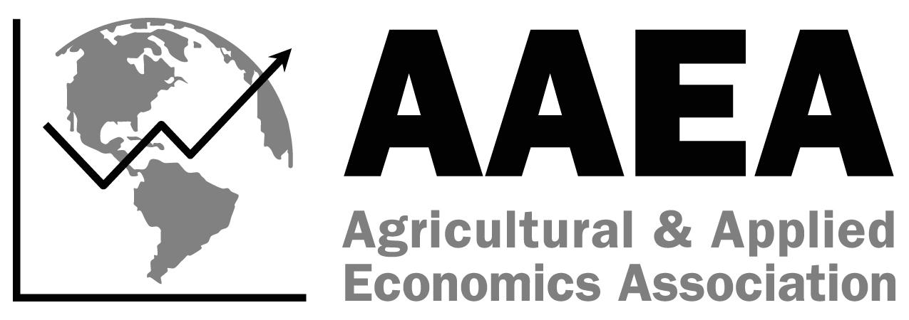
SS-AAEA
Student Paper Competition
Statement of Intent
2025 AAEA Annual Meeting
7/27-7/30, Denver, CO
Due May 16, 2025

This form is for entering the paper competition. Students who wish to submit a paper to the SS-AAEA Journal of Agricultural Economics must complete the submission form found on the website.

Please complete the fields below and return this Statement of Intent to Jessica Weister via email at jweister@aaea.org by May 16, 2025.

Paper Title: ____________________
Author’s name, email, and phone number (Note: only one student is permissible for paper competition)
____________________
University/College Affiliation(s): _______
Academic Class: Freshman Sophomore Junior Senior
Date Submitted: Expected Graduation Date: _______
Name and affiliation of advisor(s): _______

Please read and complete the following:

□ I understand entering the Undergraduate Paper Competition requires me to register for the 2025 AAEA Annual Meeting and give an oral presentation on Sunday, July 27, 2025, between 9:00 am and 5:00 pm.

If you have any questions, please contact Jessica Weister at jweister@aaea.org.

