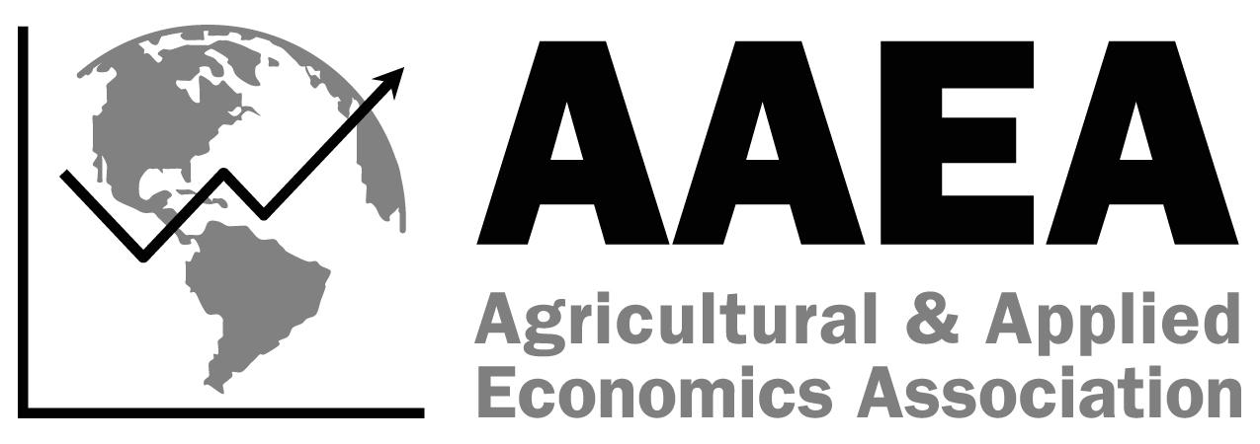
SS-AAEA
Earl O. Heady Decision Sciences
Spreadsheet Competition
Statement of Intent
2025 AAEA Annual Meeting
7/27-7/29, Denver, CO
Due May 16, 2025

Please complete the fields below and return this Statement of Intent to Jessica Weister via email at jweister@aaea.org by May 16, 2025.

Name of advisor(s): ____________________
Email: _________________________________ Phone number: _________________________________
University/College Affiliation(s): _______
Date Submitted:

Please read and complete the following:
□ I understand that there has been a format change for the Earl O. Heady Decision Sciences Spreadsheet Competition, and I have read the competition guidelines.

□ I understand that while any student may compete in the competition, it is recommended that students have taken at least introductory agricultural economics coursework and a course in agricultural data analysis (or equivalent).

□ I understand that I must complete an entry form listing the student team members by June 13, 2025.

If you have any questions, please contact Jessica Weister at jweister@aaea.org.

