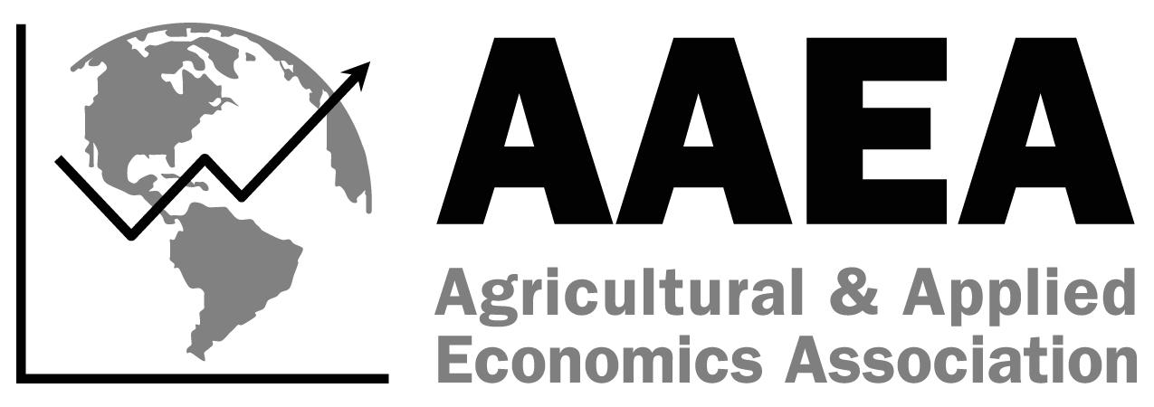
SS-AAEA
Earl O. Heady Decision Sciences
Spreadsheet Competition
Entry Form
2025 AAEA Annual Meeting
7/27-7/29, Denver, CO
Due June 13, 2025

Please complete the fields below and return this official Entry Form to Jessica Weister via email at jweister@aaea.org by June 13, 2025.
Name of advisor(s): ____________________
Email: _________________________________ Phone number: _________________________________
University/College Affiliation(s): _______

Please include the names and contact information for up to three students below. Indicate whether they are participating in quiz bowl. A student may not participate in the student paper competition and the spreadsheet competition as the contests occur simultaneously. A student may participate in the quiz bowl and spreadsheet competition as those contests occur at different times.

First Name | Last Name | Academic Class | Email Address | Participating in Quiz Bowl?

Date Submitted:

Please read and complete the following:

□ I understand that there has been a format change for the Earl O. Heady Decision Sciences Spreadsheet Competition, and I have read the competition guidelines.

□ I understand entering the Earl O. Heady Decision Sciences Spreadsheet Competition requires me to register all students for the 2025 AAEA Annual Meeting and be present for the competition on Sunday, July 27, 2025, between 8:00 a.m. and 12:00 p.m. The awards ceremony will be held in the evening on Monday, July 28, 2025.

Are you willing to help with the competition as a judge?

□ Yes
□ No

