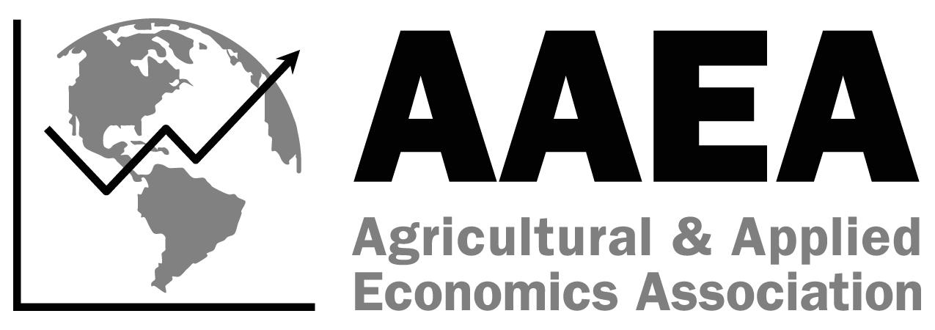
SS-AAEA
Creative Club Application
2025 AAEA Annual Meeting
7/27-7/29, Denver, CO
Due June 16, 2025
Chapter Information
University
Club Name
Contact Person E-mail
Address
City State Zip
Chapter Advisor(s)
Daytime Phone E-mail

On a separate piece of paper include:
- Summary of the creative idea
- Explanation of how the idea was implemented
- Highlight of the results
- Any suggestions you have to improve your creative idea

Please email the application to the AAEA Business Office at jweister@aaea.org and Senior Advisor English Ratliff at eratliff@umo.edu by June 16, 2025.

Note that 2025 Chapter Dues must be paid in order to participate in any of the SS-AAEA activities at the 2025 Annual Meeting. The Chapter Dues form can be found on the SS-AAEA web site. http://www.aaea.org/membership/sections/ss-aaea/

If you have any questions, please contact Jessica Weister at jweister@aaea.org or (414) 918-3190.

