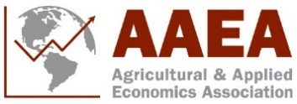
2024 Section Sponsorship Form

AAEA Section Accepting Sponsorship:

AAEA Event Being Sponsored:

Sponsor’s Name(s):

Sponsor’s Email:

Total Amount of Sponsorship Fund:
Additional Details:

Is an invoice requested?
☐ Yes
☐ No

If yes, please provide the information requested below:

Billing address:

Contact Person:

City: State: Zip:

Please send all sponsorship information to Jessica Weister (jweister@aaea.org) such as signage details if applicable to be included on the 2024 AAEA Annual Meeting website and app.

All sponsorship funds can be sent to the AAEA Business office, either by check or wire transfer. If you wish to send in the sponsorship via wire transfer, contact Jessica Weister (jweister@aaea.org) for more information.
Contact Us
Agricultural & Applied Economics Association Fax: (414) 276 3349
555 E Wells St Suite 1100, Milwaukee WI 53202 Email: info@aaea.org

