Seeds of Learning – Instructors’ Guide
- Materials you need:
  - Copies of the instructions (1 per player or group)
  - Playing cards, numbers 1-10 (i.e., remove face cards and jokers), enough for 1 per player. You can instead use index cards with numbers written on them.
    - If you want to keep face cards in, you can, and just enter them into the spreadsheet as value 10. Bear in mind that this will shift the distribution of values in the room so that the flat payment we have programmed in will no longer theoretically yield adoption by half of participants (assuming risk neutral payoff maximizers).
    - If your group is small and you randomly hand out cards from a full deck, you may randomly end up with a draw of numbers that has an expected value far from the expected value of 5.5 for the deck; this doesn’t matter a huge amount but if it bothers you, you can minimize the problem by only using part of the deck
  - Money if you plan to pay in cash; note that you may need to get permission from your institution to be able to pay participants
- Figure out roughly how many participants you will have; if the number is very large you might want to put people in pairs or trios. This group work can have additional pedagogical value.
- Prepare the spreadsheet:
  - The spreadsheet columns into which you enter information are highlighted in yellow (except for some cases in which you’ll copy and paste from another part of the spreadsheet, as explained shortly).
  - In the spreadsheet, ensure that the yellow columns are blank – delete farming values and conserve / bid decisions. (This is not essential but might reduce confusion.)
  - Drag down the spreadsheet rows to include enough positions for your group (one per player), or delete extra rows if your group is smaller.
  - You might want to adjust the yield multiplier in the “Parameters” tab of the spreadsheet for your group size. We set it to 5%, but for a larger group (e.g., 40 or more players) it might be better to have a smaller value, like 2%. If you do this, make sure you also change it in the instructions.
    - EBA adoption should be privately costly but provide public good benefits; at the same time, the externality benefit from EBA adoption shouldn’t be so large as to totally swamp other values.
    - Farming Values range from 1,000-10,000.
    - The costs of adoption (in Baseline) are 1,000 + 10% * Farming Value.
    - If you use 5%, the private benefits are 5% * Farming Value and the external benefits are (in expectation) 5% * number of other participants * 5,500 (if cards are uniformly distributed from 1-10).
  - Decide what treatments (contract periods) you want to play. You can delete the tabs of any you don’t want to play, and if you want to play any treatments more times than is already built in to the spreadsheet, you can create copies of the relevant worksheets. Adjust the “Total Earnings” tab to delete columns for treatments you are not using or add columns so all rounds are reflected.
  - Save the spreadsheet with a new name so you can store your results.
- If you want to make any modifications to the game that require the recording sheet on the last page of the instructions to be changed, change that in the “rec.sheet.for.instructions” sheet (the last tab) of the Excel workbook, and take a screen shot (we prefer to do that of a zoomed in print preview of this worksheet) and paste it into the instructions. Make it as large as possible.
- The instructions below assume you will run the game in an in-person session; if you are in a remote session, you can collect decisions using a simple Google Form or other such online interface, and after a round of decisions is complete you can just sort by ID number to copy and paste into the Excel sheet. You can do this for in-person sessions as well, especially for larger groups or if you want to keep decisions anonymous.
- If desired, modify our slides. (While the spreadsheet is pretty indispensable for this game, the slides are not, though we do provide some images and context that might be useful.)
- See the paper that accompanies this game for suggestions about leading discussions; the slides we provide also contain a few discussion questions on the final slide.
- Session setup
  - Bring up the spreadsheet on the projector
  - Bring up the slides on the projector if you plan to use the slides
  - Hand out instructions, one per player
    - We suggest distributing the instructions before the session and asking the participants to read them before the session
  - Shuffle cards and give each player a card; don’t let them choose their own
  - If you don’t feel you can interact with players and enter their data into the spreadsheet at the same time, recruit one player to be a helper. Some people don’t find this necessary, but some people feel more comfortable this way.
    - If you want to have players pass their decisions up in written form, you’ll definitely want a helper
- Go around the room asking players to call out card values, and fill in the “Card” column from sheet “1-nogov-entervalues” (the yellow column).
  - As you go, ask each player to write down his or her player number.
  - Go in a predictable order through the classroom that you will repeat for all decisions (e.g., go along each row of seats in turn) and do this quickly; set a fast pace and show an expectation that everyone will be ready to respond. This norm will make all rounds go faster.
  - Emphasize to those later in the sequence of logging decisions that they cannot change their written decisions as other are sharing the decisions.
- Advise them NOT to make their decisions for all the rounds at the outset, but to make a decision for each round in its allotted time.
- For each period:
  - Explain the specific EBA practice and policy environment for this contract period
  - Go to the tab on the spreadsheet for this treatment
  - Ask players to make their decisions and to write them down in their recording tables to commit to them.
  - Go around the room and ask players to call out decisions (adopt or no for most periods; bid value for auction). Record them in the spreadsheet.
    - If you want to ensure that players will commit to decisions before hearing others’ decisions, you can give them slips of paper to write decisions on and have them hand the decisions up to you to be recorded.
  - At the end of the round, announce the outcomes. Show the earnings column and the summary block. Tell participants to record their outcomes. Zoom in and scroll around the spreadsheet to ensure everyone can see their outcomes.
  - We find that a short discussion after each round, followed by a substantial discussion at the end, is most fruitful.
- Specific period instructions:
  - 1: No government
  - 2: Flat adoption subsidy
  - 3: Auction
    - It’s helpful to write on the board a set of ordered sample bids (e.g. $1, $2, $3, $4, $5) and circle the winners and point to the payment that would result, while explaining the process out loud. Write from lowest to highest so the winners are on top and you can circle them and point to median bid.
    - The spreadsheet should automatically determine which bids win and what the winning bid amount is.
    - More than half of the bids will win if there are ties at the median bid.
      - If you want exactly half of the bids to win, you can select the tied bids and assign random numbers to break the tie. This takes time and adds complication, so it is probably not worthwhile unless you particularly want to focus on features of the auction.
    - Make sure that you tell them (or that they can see) whether they won and what the payment was.
    - Go to the tab “bid supply curve,” select columns A and B, and sort by A (Farm Val). The bids will show up as a supply curve (where marginal costs are opportunity costs), which you can lead discussion about.
    - If anyone asks, you can note that while in all of the other periods, you should count the 5% of farming value ecosystem boost rate you would get from your own EBA adoption as part of your net incentive to adopt, in this treatment that’s no longer true because the number of parcels and thus the amount of ecosystem boost is fixed since half the bids will be accepted.
    - After the treatment, you can explain why it should be incentive compatible to bid one’s true value. We intuitively explain this by pointing out that in this mechanism, your bid influences whether you will win the auction but not how much you pay. You will never bid below your value because you might get a contract with a payment below your opportunity cost; you will never bid above it because you might miss out on a contract that you would have been willing to take. If winners were paid their bids, they would have an incentive to shade bids upward.
  - 4: Uncertain direct effect (with notes also relevant for periods 5A & B & 6A & B)
    - For this and later periods, the columns that depend on the uncertain yield have a “#VALUE” in them. This is to prevent the numbers from changing as respondent decisions are being entered (since the random number generator will regenerate when anything is typed); the uncertain yield value column is filled in with black so the values in it can’t be seen.
    - Once decisions are entered, copy the adoption effects (the blacked out values: column M (“Random direct adptn effect”) in 4, O (“Random my effect”) in 5A and 6A) and paste values (using paste-v or the menus as shown below) to column H (which is blacked out in 5A and 6A).

  - 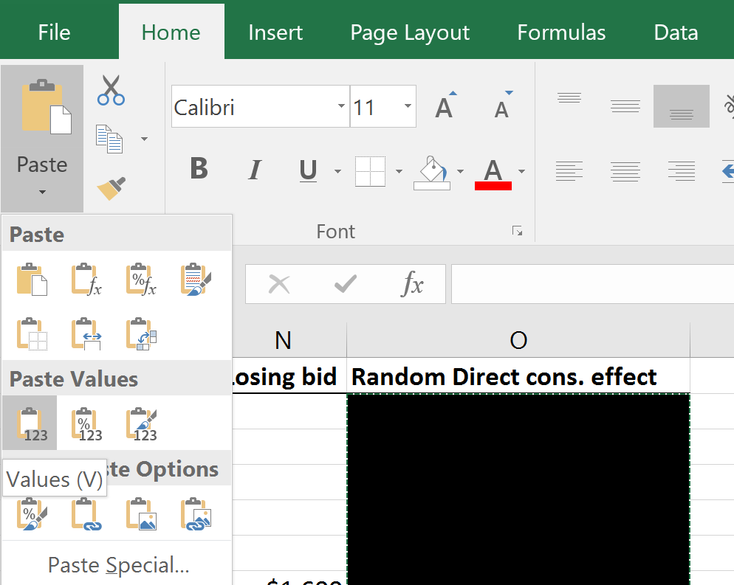
  - Figure 1: How to “Paste Values” from the Menu on Excel
    - This will now update the columns that had said “#VALUES” with actual numbers based on the realized Direct adoption effects.
    - Tell adopters their Direct adoption effects. Ask the class whether this was a good year or a bad year – it will be obvious which it was.
    - If you want participants to see the yield effect value (for transparency, to help explain why people had the yield effect amounts they got) you can copy the value from cell P10 and paste-special-values to a new blank cell or you can specify “no fill” (under Home in the Font tab) for cell P10.
  - 5A & 5B: Uncertain but correlated direct effect
    - This treatment consists of two paired periods: the first period in which the mean value of the yield distribution and the idiosyncratic effects are realized and the pilot year of decisions are made, and the second period which uses the same values from the first period.
    - Emphasize that people need not take the same action in both periods, but that the values will be the same across both periods
    - The randomness in this and the next period are hard for people to understand. Before the round, you might want to talk through a couple of normal distributions to explain the shared and idiosyncratic random effects (using the one in the slideshow we provide or sketching them on the board). Lay out two bell curves, pointing out that the mean of the distribution is randomly chosen to be high or low, and then to sequentially show some individual people’s idiosyncratic values as dots in different places on one of the distributions.
    - See guidance from period 4 above regarding copying and pasting the random values that represent the realized yields (in the blacked out cells)
    - If you want to see the mean personal direct effect, you can copy the value from cell R10 and paste-special-values to a new blank cell or specify “no fill” for the cell).
      - You are not getting new values in the second period, so you will not have to do this in the second period worksheets.
  - 6A & 6B: Pilot bonus
    - Conduct of this pair of periods is exactly like 5A & 5B; these just add a bonus automatically for adoption in the first of the paired periods.
- At the end of all rounds, go to the summary (“Total Earnings”) tab. This shows each person’s earnings in each period and adds those up, and uses the conversion factor to convert into potential dollar earnings.
- If desired (and we encourage this!), pay some participants, based on information in the “Total Earnings” tab
  - We suggest payment in cash or through a payment app right on the spot.
  - To randomly choose those to pay (which may be fairest): The spreadsheet has a “Random number” column that will recalculate whenever anything is typed in the spreadsheet. The formatting will automatically highlight the top 10% of random values. You can use this to pick 10% of the group randomly.
  - Type somewhere in the spreadsheet to recalculate the Random number column (make this moment dramatic!); then copy and paste-special-values to fix which player numbers are chosen, and sort by these values.
  - If instead you want to pay some number of participants other than 10% of the group: copy the random numbers and paste their values; select columns A-M of this sheet and sort by column M (Random number); and take as many as you want from the top of the list.
  - Alternatively, you could pay those who earned the most, to incentivize careful decision-making even more.
  - You could instead give students extra credit that is proportional to their earnings.
  - Note that in any of these cases, earnings will be heavily dependent on the card that each student randomly received; if this bothers you or your students, you can normalize earnings by Farming Value or the maximum potential earnings they could have made.
  - Yet another option is to pay some value related to group earnings to a charity chosen by the group or relevant to the environment or development.
- Save the spreadsheet and share it with the participants!

